Chat with Database (AI Use Case)

Project Background
In data-driven environments, technical teams often need to write or modify SQL queries to extract insights from large relational databases.
This process can be repetitive and time-consuming.
To streamline this, Chat with Database provides an AI-powered natural language interface where users can query MySQL or PostgreSQL databases in plain English.
Powered by LLaMA 3.2, the chatbot converts user questions into SQL, executes them, and generates a concise AI summary of the results — all within a Streamlit web application.

Problem Statement
Querying databases manually using SQL can be repetitive and time-consuming.
Technical users often spend considerable effort writing or modifying SQL queries for simple analytical tasks.
This project aims to simplify and accelerate database querying through natural language interaction backed by a robust LLM-based system.

Approach

Stage 1 – Database Connection & Schema Understanding
- Uses PyMySQL and psycopg2 for secure connections to MySQL and PostgreSQL.
- Dynamically lists available databases for user selection.
- Extracts metadata (tables, columns, primary and foreign keys) using a schema extraction layer.

Stage 2 – Natural Language to SQL Conversion (LLM Integration)
- A structured prompt including schema and user query is sent to LLaMA 3.2 via the Hugging Face API.
- The model returns a clean SQL query, free of extra text or comments.
- The SQL is validated to ensure safety (only SELECT, SHOW, or DESCRIBE queries are allowed).

Stage 3 – Query Execution, Visualization & Summarization
- The validated SQL query is executed on the connected database.
- The query results are displayed in a formatted table using Pandas and Streamlit (with readable column names).
- The system also generates a summary of key insights from the results using LLaMA 3.2’s reasoning capabilities.

Major Components and Functions
Function / Module | Purpose
get_mysql_connection() / get_postgres_connection() | Establishes secure DB connections using credentials from .env.
list_mysql_databases() / list_postgres_databases() | Lists all databases on the connected server.
get_database_schema() | Fetches schema details — tables, columns, keys, relationships.
generate_sql() | Sends schema and user question to LLaMA 3.2 and returns a valid SQL query.
summarize_results() | Generates a 2–3 sentence natural language summary of query results.
Streamlit UI | Radio buttons for platform selection, database dropdown, query input, expander for schema/SQL, and summary output.

Implementation Overview
Technologies Used:
- streamlit → Web interface
- pandas → Result structuring and table display
- pymysql / psycopg2 → Database connectivity
- huggingface_hub → LLaMA 3.2 model inference
- dotenv → Secure environment variable handling
- re → Column name formatting (readable output)
Security:
All API keys and credentials are stored in a .env file, ensuring safe and modular configuration.

Pros / Advantages
- Reduces manual SQL writing effort for technical users.
- Supports multi-database querying (MySQL + PostgreSQL).
- Provides instant AI summaries of query results.
- Schema and results visualized cleanly using Streamlit.
- Modular design — can easily integrate with other SQL engines or LLMs.
- Secure API and credential management.

Scope and Future Enhancements
Current Scope:
- Supports direct connectivity with MySQL and PostgreSQL.
- Generates and validates SQL via LLaMA 3.2.
- Displays and summarizes query results dynamically.
Future Enhancements:
- Integration with cloud databases (AWS RDS, Azure SQL, Google Cloud SQL).
- Addition of graphical data insights (charts, KPIs).
- Saving query history and generating automated reports.

Stakeholders / Target Audience
- Data Engineers & Developers – Simplify complex query building.
- Business Analysts – Accelerate data retrieval and report generation.
- Project Managers / Tech Leads – Gain quick insights for decision-making.
- Organizations – Improve productivity in database operations.

System Workflow
- User selects database platform (MySQL / PostgreSQL).
- Chatbot fetches list of available databases.
- Schema is extracted from the selected database.
- User enters a natural language question.
- LLaMA model converts it into SQL.
- SQL is executed and results are displayed.
- AI generates a concise summary of the output.

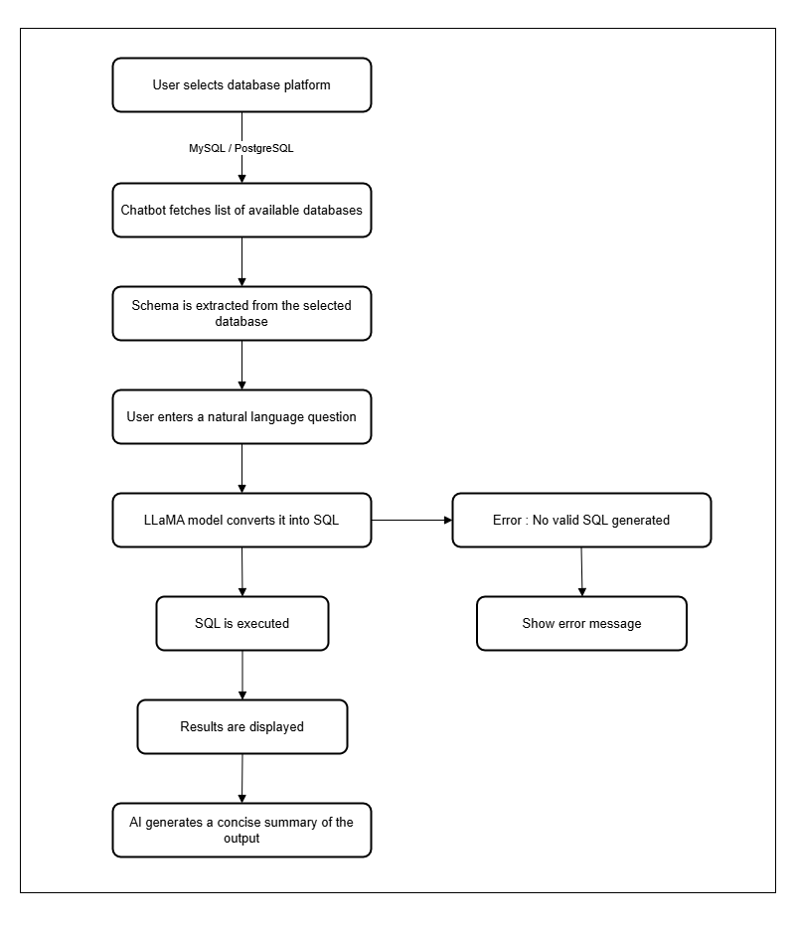
DFD Level 0

